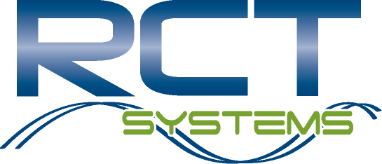

Employee Referral Form

Referral Guidelines
- To refer a potential employee, please complete this form and return it, along with a copy of the prospective candidate’s current resume and application to the Human Resource department.
- You are eligible for a referral award only when you refer candidates who are not current RCT employees.
- If the candidate you refer is hired, you will receive a referral award of $10,000 ($5,000 after the new employee is hired and another $5000 after the individual has worked for RCT Systems for 90 days). Must be a current employee to receive each payout.
- Employees involved in the hiring decision for a particular position are not eligible for referral awards for that position.
- Only one referral award can be given per candidate. If a candidate is referred by more than one employee then the first referral received will be the one rewarded if the candidate is hired.

Employee Information
Employee Name: |  |  |  |  |  |  |  |  |  |  |  |  | Date:
Division:
E-Mail Address: |  |  |  |  |  |  |  |  | Telephone Number:

Referral Information
Candidate Name:
E-Mail Address: |  |  |  |  |  |  |  |  | Telephone Number:
Position Referred For:
Why this candidate is qualified for this position:

For Human Resources Use Only
Date Received: |  |  |  |  |  |  |  |  | Interviewed
Hired: |  |  |  |  |  |  |  |  | Award Date:

Approval: _________________________________________

